## **Classification Model performance and key insights on the data**

We tried Logistic Regression, Decision Tree, Random Forest and XGBoost algorithm to train the data and used accuracy score to evaluate each model performance.

Plotting the accuracy as a bar chart –

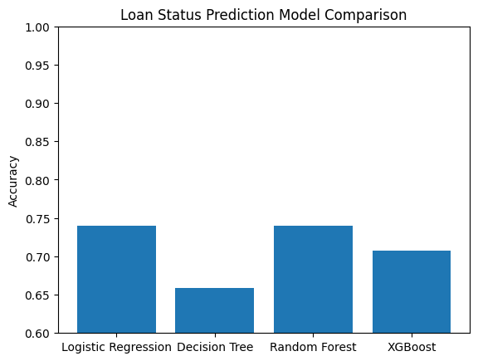

Both Logistic Regression and Random Forest has the highest accuracy score - **0.7398373983739838**

## **Regression Model performance and key insights on the data**

We tried Linear Regression, Random Forest and XGBoost algorithm to train the data and used mean absolute error, mean squared error and R-squared error to evaluate each model performance.

Among these, XGBoost has the highest R-squared error - **0.09500721221818065**